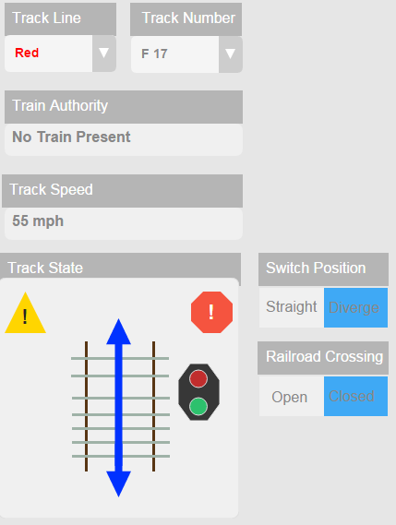**Track Controller User’s Manual**

**Railroad Crossing**

If the selected track is a Railroad Crossing, the Railroad Crossing switch will appear. When the switch is set to Open, cars will be allowed to cross. When the switch is set to Closed, the crossing lights will be on and the gates will stop traffic

**Track Number**

Select a Track number from the dropdown menu. Tracks in the selected line will be shown once a track is selected

**Switch Position**

If the selected track is a switch track Switch Position will appear. Press Straight or Diverge to set the track switch position respectively

**Track State**

The track State box will display a variety of icons depending on the current track selected. A section of track will represent what type of track it is. A blue arrow will represent the direction a switch track switch set. Any lights on the track will be displayed with corresponding icons next to the track. A yellow or red warning icon will appear if the track is malfunctioning or if there is an error

**Track Speed**

The selected section of track’s speed limit will be displayed under Track Speed

**Track Line**

Select a Track Line from one of the existing tracks in the dropdown menu

**Train Authority**

Train Authority will display the name of a train on the selected track and it’s authority, or “No Train Present” if no train is detected